|  |  |
| --- | --- |
| **WC Logo.emf** | **Staff Report to the Weber County Commission**  *Weber County Planning Division* |
|  | |

****Synopsis****

****Application Information****

**Application Request:** A public hearing to consider and take action on a request to vacate the 10-foot public utility easements located on both sides of the shared lot line between lots 2 and 3 of Sun Dance Ridge Subdivision.

**Agenda Date: Tuesday, May 4, 2021**

**Applicant:** Wyatt Burton

**File Number:** EV2021-04

****Property Information****

**Approximate Address: 5608 E 1700 S, 5605 E 1700 S**, Liberty, 84317

**Project Area:** 6.05 Acres

**Zoning:** Forest Valley (FV-3)

**Existing Land Use:** Residential

**Proposed Land Use:** Residential

**Parcel ID:** 20-125-0002, 20-125-0003

**Township, Range, Section:** T6N, R1E, Section 23

****Adjacent Land Use****

**North:** Residential **South:** Residential

**East:** Residential **West:** Residential

****Staff Information****

**Report Presenter: Felix Lleverino**

flleverino@webercountyutah.gov

**801-399-8767**

**Report Reviewer:** SB

Development History

Sundance Ridge Subdivision was recorded in the Weber County Recorder’s Office on July 25, 2008.

Background and Summary

The applicant has submitted a request to vacate the 10-foot public utility easements located on both sides of the shared lot line between lots 2 and 3 of the Sun Dance Ridge Subdivision. The property owner of both lots is requesting the vacation of the public utility easement to allow for the placement of a single-family dwelling.

The applicant has proposed to vacate the public utility easement by ordinance and amended plat. Under Utah State Code, Section 17-27a-609.5, the legislative body may adopt an ordinance granting a petition to vacate some or all of a public street, right-of-way, or easement if the legislative body finds that:

(a) good cause exists for the vacation; and

(b) neither the public interest nor any person will be materially injured by the vacation.

The vacating procedure found in Utah State Code 17-27a-208 and 17-27a-209.5 does not require a Planning Commission recommendation.

The following is the staff's analysis of the vacation request.

Analysis

*General Plan*: Vacating this easement does not conflict with the Ogden Valley General Plan.

*Additional Standards*: Utah State notice procedures (17-27a-208) have been followed for this petition to vacate. Any comments or objections to this proposal may be heard before or during a public hearing that is being held on May 4, 2021.

*Agency Review*: Engineering is ready to approve this vacation. Planning will record the ordinance after the 15-day waiting period has lapsed.

Staff Recommendation

Staff recommends approval of the request to vacate the 10-foot public utility easements located on both sides of the shared lot line between lots 2 and 3 of the Sun Dance Ridge Subdivision. This recommendation for approval is subject to all review agency requirements and is based on the following condition:

1. The ordinance to vacate the public utility easement will be recorded.

This recommendation for approval is based on the following findings:

1. Vacating the proposed easement does not conflict with the Ogden Valley General Plan.
2. The public interest or any person will not be materially injured by the proposed vacation.
3. The proposed vacation will not be detrimental to public health, safety, or welfare.
4. The proposed vacation will not deteriorate the environment of the general area to negatively impact surrounding properties and uses.

Exhibits

1. Depiction of the area being vacated
2. Easement Vacation Ordinance

Area Map

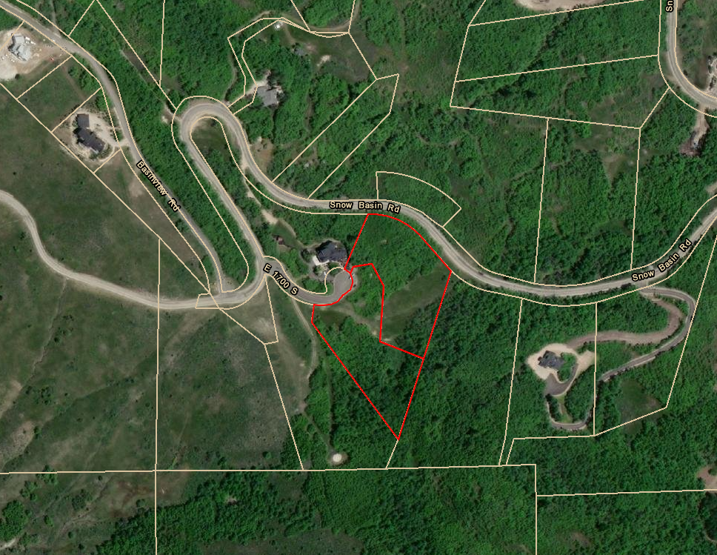

Exhibit A

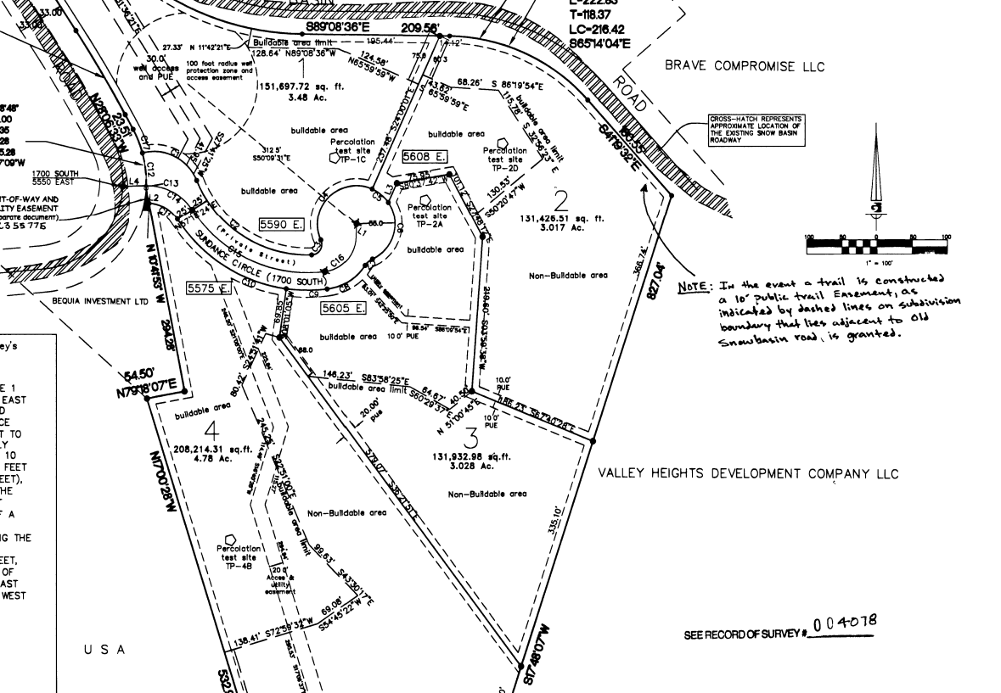

Exhibit B

**Ordinance**

**An ordinance of Weber County vacating the 10-foot public utility easements located on the shared lot line between lots 2 and 3 of the Sun Dance Ridge Subdivision**

**Whereas**, the residential lot 2 and 3 are described in a plat named “Sun Dance Ridge Subdivision,” recorded in the Weber County Recorder’s Office on July 25, 2008 as Entry number 2355773; and

**Whereas,** Wyatt M. Burton, the legal lot owners of Lots 2 and 3 of the Sundance Ridge Subdivision, have filed a petition to vacate the 10-foot public utility easements located on the shared lot line between lots 2 and 3 of Sun Dance Ridge Subdivision; and

**Whereas,** after providing proper public notice, a public hearing was held on May 4, 2021, regarding the vacation of the 10-foot public utility easements located within Lots 2 and 3 of the Sundance Ridge Subdivision; and

**Whereas,** The Weber County Engineering Department has been notified and has provided written approval of the vacation of the public utility easement located within Lots 2 and 3 of the Sun Dance Ridge Subdivision; and

**Whereas,** the Board of County Commissioners finds that the vacation of the public utility easement within Lots 2 and 3 of the Sun Dance Ridge Subdivision will not substantially affect the Ogden Valley General Plan or the health, safety, and welfare of the general public;

**Now, Therefore,** the Board of County Commissioners of Weber County ordains as follows: The following public utility easements located within Lots 2 and 3 of the Sun Dance Ridge Subdivision, which is described in Entry number 2355773 of the Weber County Recorder’s Office, is hereby vacated from the subdivision:

**The 10-foot public utility easements located on shared lot line between lots 2 and 3 of the Sun Dance Ridge Subdivision, as highlighted with cross hatches on the 2021 Recorder’s plat (20-125) in Exhibit A, is hereby vacated from said lot.**

**This Ordinance shall be effective 15 days after publication in the Standard Examiner.**

Passed, adopted, and ordered published this day of , 2021, by the Board of County Commissioners of Weber County.

(*signatures on following page*)

BOARD OF COUNTY COMMISSIONERS OF WEBER COUNTY

By___________________________________

James H. “Jim” Harvey, Chair

Commissioner Harvey Voting

Commissioner Froerer Voting

Commissioner Jenkins Voting

ATTEST:

Ricky Hatch, CPA

Weber County Clerk

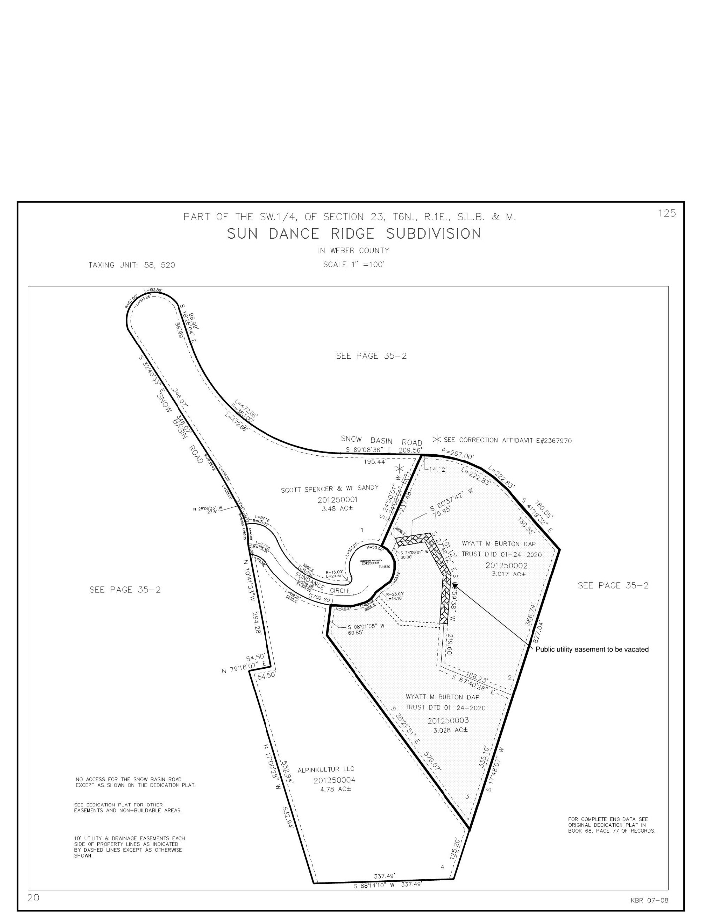

Exhibit A